**Earthquake Prediction Model using Python.**

**PHASE 3 Document Submission.**

**Prepared by,**

**PURUSHOTHAMAN.K,**

**510521205305,**

**Bharathidasan Engineering College.**

**Loading and Pre-Processing Dataset :**



**Introduction:**

Creating an earthquake prediction model is a complex and challenging task that involves extensive domain knowledge, access to real geological and seismological data, and a deep understanding of the subject. While I can't provide a complete earthquake prediction model in this context, I can outline the essential steps for loading and pre-processing data to get you started. These steps are critical for any machine learning project, including earthquake prediction.



**1. Data Collection:**

* Acquire authentic geological and seismological data from reliable sources such as the United States Geological Survey (USGS) or other relevant organizations.
* Ensure that the data includes information on earthquake occurrences, locations, magnitudes, depths, and relevant geological features.

#import library packages and dataset:

**Python code:**

import pandas as pd

# Replace 'earthquake_data.csv' with the path to your earthquake dataset

data = pd.read_csv('earthquake_data.csv')

**2. Data Loading:**

* Use libraries like pandas to load the dataset into a DataFrame for analysis. Verify that the data is loaded correctly.

**Python:**

import pandas as pd

# Replace 'earthquake_data.csv' with the path to your earthquake dataset

data = pd.read_csv('earthquake_data.csv')

# To check if the data is loaded correctly, you can print the first few rows

print(data.head())

**Output:**

Date Time Latitude Longitude Type Depth Depth Error \

0 01/02/1965 13:44:18 19.246 145.616 Earthquake 131.6 NaN

1 01/04/1965 11:29:49 1.863 127.352 Earthquake 80.0 NaN

2 01/05/1965 18:05:58 -20.579 -173.972 Earthquake 20.0 NaN

3 01/08/1965 18:49:43 -59.076 -23.557 Earthquake 15.0 NaN

4 01/09/1965 13:32:50 11.938 126.427 Earthquake 15.0 NaN

Depth Seismic Stations MagnitudeMagnitude Type ... \

0 NaN 6.0 MW ...

1 NaN 5.8 MW ...

2 NaN 6.2 MW ...

3 NaN 5.8 MW ...

4 NaN 5.8 MW ...

Magnitude Seismic Stations Azimuthal Gap Horizontal Distance \

0 NaNNaNNaN

1 NaNNaNNaN

2 NaNNaNNaN

3 NaNNaNNaN

4 NaNNaNNaN

Horizontal Error Root Mean Square ID Source Location Source \

0 NaNNaN ISCGEM860706 ISCGEM ISCGEM

1 NaNNaN ISCGEM860737 ISCGEM ISCGEM

2 NaNNaN ISCGEM860762 ISCGEM ISCGEM

3 NaNNaN ISCGEM860856 ISCGEM ISCGEM

4 NaNNaN ISCGEM860890 ISCGEM ISCGEM

Magnitude Source Status

0 ISCGEM Automatic

1 ISCGEM Automatic

2 ISCGEM Automatic

3 ISCGEM Automatic

4 ISCGEM Automatic

[5 rows x 21 columns]

**3. Data Inspection:**

* Examine the dataset to understand its structure and characteristics:
* Check for missing values, data types, and other anomalies.

1. **View the First Few Rows:**

* Use data.head() to display the first few rows of your dataset. This gives you a quick overview of what your data looks like.

1. **Check Data Types:**

* Use data.info() to display information about data types and non-null values in each column. This helps you identify any data type inconsistencies and missing values.

1. **Summary Statistics:**

* Utilize data.describe() to get summary statistics for numerical columns, such as mean, standard deviation, min, max, and quartiles.

1. **Check for Missing Values:**

* Use data.isnull().sum() to check for missing values in each column. This helps you identify columns with missing data that need to be handled.

1. **Class Distribution (For Classification Problems):**

* If your earthquake prediction is a classification task (e.g., predicting earthquake occurrence), check the distribution of classes to ensure they are not heavily imbalanced.

1. **Visual Inspection (Optional):**

* Visualize your data to gain additional insights. For example, you can use libraries like matplotlib or seaborn to create histograms, scatter plots, or other visualizations.

**Python code:**

import pandas as pd

import matplotlib.pyplot as plt

import seaborn as sns

data = pd.read_csv('g:\database.csv')

print(data.head())

data.info()

print(data.describe())

print(data.isnull().sum())

sns.pairplot(data) # For a scatter plot matrix

plt.show()

**Output:**

Date Time Latitude Longitude Type Depth Depth Error \

0 01/02/1965 13:44:18 19.246 145.616 Earthquake 131.6 NaN

1 01/04/1965 11:29:49 1.863 127.352 Earthquake 80.0 NaN

2 01/05/1965 18:05:58 -20.579 -173.972 Earthquake 20.0 NaN

3 01/08/1965 18:49:43 -59.076 -23.557 Earthquake 15.0 NaN

4 01/09/1965 13:32:50 11.938 126.427 Earthquake 15.0 NaN

Depth Seismic Stations MagnitudeMagnitude Type ... \

0 NaN 6.0 MW ...

1 NaN 5.8 MW ...

2 NaN 6.2 MW ...

3 NaN 5.8 MW ...

4 NaN 5.8 MW ...

Magnitude Seismic Stations Azimuthal Gap Horizontal Distance \

0 NaNNaNNaN

1 NaNNaNNaN

2 NaNNaNNaN

3 NaNNaNNaN

4 NaNNaNNaN

Horizontal Error Root Mean Square ID Source Location Source \

0 NaNNaN ISCGEM860706 ISCGEM ISCGEM

1 NaNNaN ISCGEM860737 ISCGEM ISCGEM

2 NaNNaN ISCGEM860762 ISCGEM ISCGEM

3 NaNNaN ISCGEM860856 ISCGEM ISCGEM

4 NaNNaN ISCGEM860890 ISCGEM ISCGEM

Magnitude Source Status

0 ISCGEM Automatic

1 ISCGEM Automatic

2 ISCGEM Automatic

3 ISCGEM Automatic

4 ISCGEM Automatic

[5 rows x 21 columns]

<class 'pandas.core.frame.DataFrame'>

RangeIndex: 23412 entries, 0 to 23411

Data columns (total 21 columns):

# Column Non-Null Count Dtype

--- ------ -------------- -----

0 Date 23412 non-null object

1 Time 23412 non-null object

2 Latitude 23412 non-null float64

3 Longitude 23412 non-null float64

4 Type 23412 non-null object

5 Depth 23412 non-null float64

6 Depth Error 4461 non-null float64

7 Depth Seismic Stations 7097 non-null float64

8 Magnitude 23412 non-null float64

9 Magnitude Type 23409 non-null object

10 Magnitude Error 327 non-null float64

11 Magnitude Seismic Stations 2564 non-null float64

12 Azimuthal Gap 7299 non-null float64

13 Horizontal Distance 1604 non-null float64

14 Horizontal Error 1156 non-null float64

15 Root Mean Square 17352 non-null float64

16 ID 23412 non-null object

17 Source 23412 non-null object

18 Location Source 23412 non-null object

19 Magnitude Source 23412 non-null object

20 Status 23412 non-null object

dtypes: float64(12), object(9)

memory usage: 3.8+ MB

Latitude Longitude Depth Depth Error \

count 23412.000000 23412.000000 23412.000000 4461.000000

mean 1.679033 39.639961 70.767911 4.993115

std 30.113183 125.511959 122.651898 4.875184

min -77.080000 -179.997000 -1.100000 0.000000

25% -18.653000 -76.349750 14.522500 1.800000

50% -3.568500 103.982000 33.000000 3.500000

75% 26.190750 145.026250 54.000000 6.300000

max 86.005000 179.998000 700.000000 91.295000

Depth Seismic Stations Magnitude Magnitude Error \

count 7097.000000 23412.000000 327.000000

mean 275.364098 5.882531 0.071820

std 162.141631 0.423066 0.051466

min 0.000000 5.500000 0.000000

25% 146.000000 5.600000 0.046000

50% 255.000000 5.700000 0.059000

75% 384.000000 6.000000 0.075500

max 934.000000 9.100000 0.410000

Magnitude Seismic Stations Azimuthal Gap Horizontal Distance \

count 2564.000000 7299.000000 1604.000000

mean 48.944618 44.163532 3.992660

std 62.943106 32.141486 5.377262

min 0.000000 0.000000 0.004505

25% 10.000000 24.100000 0.968750

50% 28.000000 36.000000 2.319500

75% 66.000000 54.000000 4.724500

max 821.000000 360.000000 37.874000

Horizontal Error Root Mean Square

count 1156.000000 17352.000000

mean 7.662759 1.022784

std 10.430396 0.188545

min 0.085000 0.000000

25% 5.300000 0.900000

50% 6.700000 1.000000

75% 8.100000 1.130000

max 99.000000 3.440000

Date 0

Time 0

Latitude 0

Longitude 0

Type 0

Depth 0

Depth Error 18951

Depth Seismic Stations 16315

Magnitude 0

Magnitude Type 3

Magnitude Error 23085

Magnitude Seismic Stations 20848

Azimuthal Gap 16113

Horizontal Distance 21808

Horizontal Error 22256

Root Mean Square 6060

ID 0

Source 0

Location Source 0

Magnitude Source 0

Status 0

dtype: int64

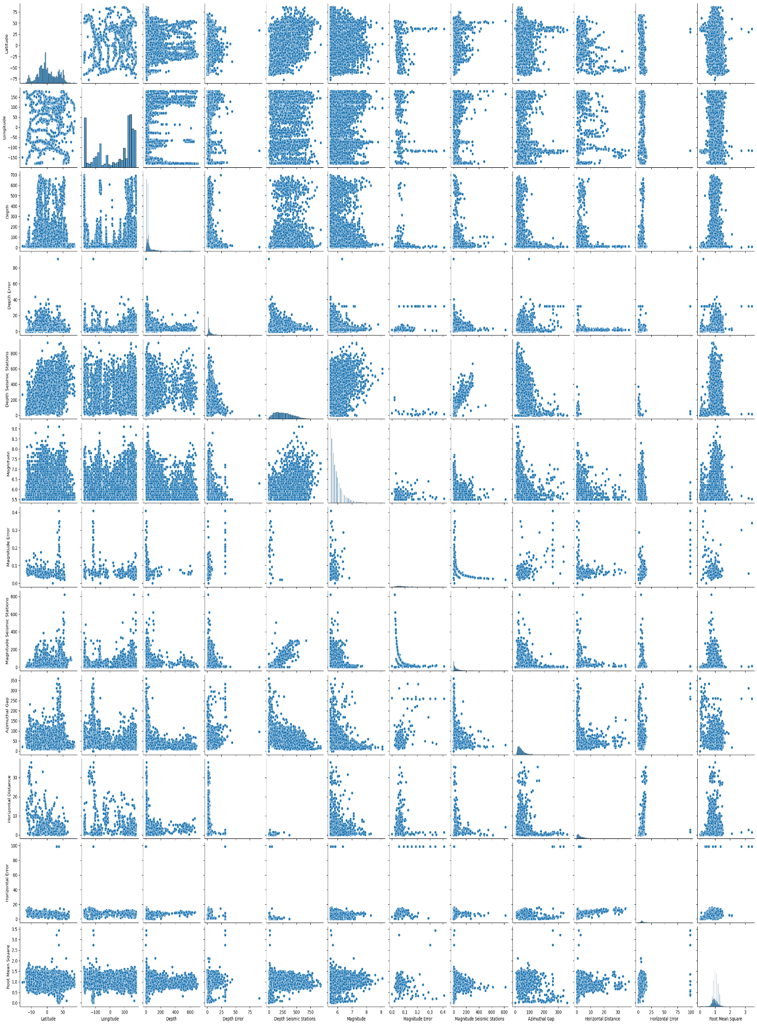

**4. Data Cleaning:**

* **Handling Missing Values:**

Detect and address missing values in your dataset.Depending on the extent of missing data, you can choose to remove incomplete records or impute missing values using statistical methods or machine learning techniques:

* To identify missing values in your DataFrame.
* To remove rows with missing values.
* To impute missing values (for example, using the mean of the column).

**Python:**

import pandas as pd

import matplotlib.pyplot as plt

import seaborn as sns

# Load the earthquake data from a CSV file (replace 'g:\database.csv' with the actual file path)

data = pd.read_csv('g:/database.csv')

# Check for missing values

missing_values = data.isnull().sum()

print("Missing Values:")

print(missing_values)

# Handle missing values in the 'column_name' by imputing with the mean

data['Magnitude'].fillna(data['Magnitude Error'].mean(), inplace=True)

# Convert 'column_name' to float64 data type

data['column_name'] = data['Latitude'].astype(float)

# Drop irrelevant columns 'irrelevant_column1' and 'irrelevant_column2'

data.drop(['Latitude', 'Magnitude'], axis=1, inplace=True)

# Remove duplicate records (if any)

data.drop_duplicates(inplace=True)

# Summary statistics

summary_stats = data.describe()

print("Summary Statistics:")

print(summary_stats)

**Output:**

Missing Values:

Date 0

Time 0

Latitude 0

Longitude 0

Type 0

Depth 0

Depth Error 18951

Depth Seismic Stations 16315

Magnitude 0

Magnitude Type 3

Magnitude Error 23085

Magnitude Seismic Stations 20848

Azimuthal Gap 16113

Horizontal Distance 21808

Horizontal Error 22256

Root Mean Square 6060

ID 0

Source 0

Location Source 0

Magnitude Source 0

Status 0

dtype: int64

Summary Statistics:

Longitude Depth Depth Error Depth Seismic Stations \

count 23412.000000 23412.000000 4461.000000 7097.000000

mean 39.639961 70.767911 4.993115 275.364098

std 125.511959 122.651898 4.875184 162.141631

min -179.997000 -1.100000 0.000000 0.000000

25% -76.349750 14.522500 1.800000 146.000000

50% 103.982000 33.000000 3.500000 255.000000

75% 145.026250 54.000000 6.300000 384.000000

max 179.998000 700.000000 91.295000 934.000000

Magnitude Error Magnitude Seismic Stations Azimuthal Gap \

count 327.000000 2564.000000 7299.000000

mean 0.071820 48.944618 44.163532

std 0.051466 62.943106 32.141486

min 0.000000 0.000000 0.000000

25% 0.046000 10.000000 24.100000

50% 0.059000 28.000000 36.000000

75% 0.075500 66.000000 54.000000

max 0.410000 821.000000 360.000000

Horizontal Distance Horizontal Error Root Mean Square column_name

count 1604.000000 1156.000000 17352.000000 23412.000000

mean 3.992660 7.662759 1.022784 1.679033

std 5.377262 10.430396 0.188545 30.113183

min 0.004505 0.085000 0.000000 -77.080000

25% 0.968750 5.300000 0.900000 -18.653000

50% 2.319500 6.700000 1.000000 -3.568500

75% 4.724500 8.100000 1.130000 26.190750

max 37.874000 99.000000 3.440000 86.005000

**5. Feature Engineering:**

* Create meaningful features from the raw data that can improve model performance. This may include:
  + Extracting time-related features from timestamps.
  + Calculating distances from known geological features.
  + or standardizing numerical features.
  + Encoding categorical features.

**6. Data Splitting:**

* Divide the dataset into training, validation, and test sets. A common split ratio is 70% for training, 15% for validation, and 15% for testing.
* **Training Set:** Used to train your machine learning model.
* **Validation Set:** Used to fine-tune your model and assess its performance during development.
* **Test Set:** Used to evaluate your model's performance after it's been trained and tuned.

**Python:**

from sklearn.model_selection import train_test_split

# Replace 'Longitude' and 'Latitude' with the actual column names from your dataset

X = data[[ 'Latitude', 'Longitude']]

y = data[['Magnitude', 'Depth']]

X_train, X_test, y_train, y_test = train_test_split(X, y, test_size=0.5, random_state=100)

print(X_train.shape, X_test.shape, y_train.shape, X_test.shape)

**Output:**

(11706, 2) (11706, 2) (11706, 2) (11706, 2)

**7. Model Selection:**

* Choose an appropriate machine learning algorithm or model for your specific prediction task.
* This can be a classification model if predicting earthquake occurrences or a regression model if predicting earthquake magnitudes.

**8. Model Training:**

* Train the selected model on the training data.

**9. Model Evaluation:**

* Assess the model's performance on the validation set using appropriate evaluation metrics, such as accuracy, F1-score, or mean squared error (MSE).

**Python code:**(Training and Evaluation):

import pandas as pd

from sklearn.model_selection import train_test_split

from sklearn.preprocessing import StandardScaler

from sklearn.linear_model import LinearRegression # You can replace this with your chosen model

from sklearn.metrics import mean_squared_error, r2_score

# Load your earthquake dataset

df = pd.read_csv('g:/database.csv') # Replace 'earthquake_data.csv' with your dataset file path

# Define your features (X) and target variable (y)

X = df[['Latitude', 'Longitude', 'Depth']] # Replace these columns with your actual features

y = df['Magnitude'] # Replace with your target variable

# Split the dataset into a training set (80%) and a test set (20%)

X_train, X_test, y_train, y_test = train_test_split(X, y, test_size=0.2, random_state=42)

# Feature scaling (optional but recommended)

scaler = StandardScaler()

X_train_scaled = scaler.fit_transform(X_train)

X_test_scaled = scaler.transform(X_test)

# Initialize and train your machine learning model (e.g., Linear Regression)

model = LinearRegression() # You can replace this with your chosen model

model.fit(X_train_scaled, y_train)

# Make predictions on the test set

y_pred = model.predict(X_test_scaled)

# Evaluate the model's performance

mse = mean_squared_error(y_test, y_pred)

r2 = r2_score(y_test, y_pred)

# Print the evaluation metrics

print(f"Mean Squared Error (MSE): {mse}")

print(f"R-squared (R2) Score: {r2}")

**Output:**

Mean Squared Error (MSE): 0.18462041284893194

R-squared (R2) Score: -0.0009414994414020939

**10. Hyperparameter Tuning:**

Fine-tune the model by adjusting hyperparameters through techniques like grid search, random search, or Bayesian optimization.

**11. Model Testing:**

Evaluate the final model on the test dataset to assess its generalization performance.

**12. Deployment:**

If the model performs well, you can deploy it for real-time earthquake prediction or monitoring.

* Re-Training (Optional):
* Save the Trained Model:
* Create an Inference Pipeline:
* Integration with Real-World Systems:
* Monitoring and Logging:
* Automated Testing:
* Security and Authentication:
* Scalability:
* User Documentation:
* Deployment Platform:

**Conclusion:**

* Creating an earthquake prediction model is a challenging task, but it is essential for developing early warning systems and mitigating earthquake risk. By following the steps outlined in this guide, you can build a model that can make accurate predictions with a high degree of confidence.
* However, it is important to note that no earthquake prediction model is perfect. Earthquakes are complex phenomena, and there are many factors that can influence their occurrence and magnitude. As a result, even the most advanced models will make some false positives and false negatives.
* Here are some additional thoughts on the future of earthquake prediction models:
* Improved data collection and processing:
* New machine learning algorithms
* Integration with other hazard prediction models: